**Selection of Stable and High-Performing Mung Bean (*(Vigna radiata (L.)* R. Wilczek) Genotypes for Post-Fertility Traits in Response to Phytohormone Treatment (GA3 50mg/l + NAA 50mg/l) in Chitwan, Nepal.**

Bikas Basneta* Umisha Upretya Krishna Prasad Thapaliya**b**

aFaculty of Agriculture, Agriculture and Forestry University, Bharatpur, Nepal.

bDepartment of Rural Sociology and Development Studies, Agriculture and Forestry University, Bharatpur, Nepal.

aCorresponding author email: [bikasbasnet2001@gmail.com](mailto:bikasbasnet2001@gmail.com)

ORCHID iD*: 0000-0003-0579-6039

**ABSTRACT**

Germplasms assessment for economic traits, considering genetic potential and the use of growth promoters, is vital for mung improvement. Single Factorial complete block design with 3 replications was performed to multivariate selection using Multi Genotype Ideotype Distance Indexing and analysis of variance with Duncan's test at (p ≤ 0.05) to compare the means of yield attributes. A combined application of standard research rate GA3 (50 mg/L) and NAA (50 mg/L) was performed at 30% and mean flowering stages. Factorial analysis and correlation study revealed that flower shedding before and 12 hours after spraying is deleterious to yield shows negative sense. Yield/plant was s positively (p<0.001, r=0.67-0.96) correlated with harvesting index and grain test weight. 'Pratigya' bloomed sensitively, VC3960A-88 flourished with hormone-boosted pod formation. 'VC6368(46-40-3)' packed 11 pods/cluster, and 'CN95' thrived with both abundant grains and clusters. Notably, 'VC6370-A' topped yielder, while CN95 boasted an efficient harvest index of (0.48). At a 17% selection intensity, MGIDI revealed that 'VC6370A' and 'CN95' are the ideal stable and superior mean performance genotypes for yield (3.04 to 2.8 tons/ha) scope in simultaneous selection and improvement. The MGIDI's view of strengths and weaknesses indicates that breeders should focus on creating genotypes with desired phenotypes, such as lower flower shedding, higher grain dimensions & pod setting, harvesting index, and yield/ha.

**Keywords:** Mung bean improvement, Multivariate selection, Genetic potential, Growth promoters, Ideal genotypes, High yield, Future breeding

1. **INTRODUCTION**

Mung bean in the tropics and subtropics is a legume crop that grows quickly (55-75 days) and pollinates itself. It has 22(diploid) chromosomes, except for the variety V. *reflexa pilosa*, which has 44(Tetraploid). The experimental variety V. radiata var. radiata VC1973A and its relatives has a genome size of 475-579.35 million base pairs[1][2]. Mung bean is a low-cost source of nutrients, including 60-65% carbohydrates, 20.97-31.32% protein (compared to 20-30% in soy and kidney beans), and 1-1.5% fat content. It is also a excellent source of iron and folate reviewed by [3][4][5]. Mung bean is widely grown in Nepal's Terai region, particularly in the eastern and central regions where irrigation is accessible. The western Terai and foothills account for the remaining 25% of mung bean production. About 12,000 hectares are used for mung bean farming, yielding a yield of 6,500 tons and a productivity of 600 kg per hectare indicating the low production of grain compared with global average Production of 2.8 to 3 tons/ha(Krishi Diary ,2079). Mung bean production is often challenged by climate crisis such as severe droughts, poor and inappropriate agricultural practices, and insufficient breeding efforts to develop new mung bean varieties with preferable traits such as high yield, drought tolerance, and disease resistance. These challenges can significantly reduce yield stability and harm the livelihoods of smallholder farmers.

**Genetic diversity is essential for improving the climate resilience of mung bean genotypes with different genetic backgrounds and farmers can reduce the risk of crop failure if one genotype is susceptible to a particular stress.** The amount of grain that a green gram plant produces is influenced by many factors, including its genes, the environment in which it is grown, and how it is managed. This helps to identify and select promising genotypes for recommendation and improvement. Multi Traits ideotype distance indexing **can be used to predict the genetic value of individual plants. Selection indexes are a better way to improve selection efficiency because they allow for the simultaneous selection of multiple traits, resulting in genotypes that are closer to the ideal**. The biggest drawback of the classic linear selection index is the need to specify the economic weight of each trait, genotypic and phenotypic variances and covariances, and its vulnerability to multicollinearity[7].The stability index proposed by [8] allows for the selection of stable genotypes with favorable selection differentials for traits to be increased and unfavorable selection differentials for traits to be decreased. The index technique used by [9]can also be used to assess the strengths and weaknesses of genotypes. This stability index is thus useful for simultaneously selecting for average performance and stability across multiple traits. It offers a new and simple way to select genotypes that considers how different traits are related to each other.

**Mung bean plants have indeterminate pod maturity, meaning that they continue to produce flowers and pods throughout the growing season. This requires multiple harvests to avoid wasting pods. Phytohormones, which are plant hormones that regulate many aspects of plant growth and development, can be used to improve several mung bean post-fertility traits, including pod number, grain number, grain weight, and grain quality[10].**Nitrate reductase activity is increased by GA3, leading to higher protein content in cowpea, black cumin, and mung-bean[11]**. Exogenous application of phytohormones may affect *'FERONIA'*, a known flowering-pathway gene that is a candidate for the quantitative trait locus (QTL) with the largest effect on days to flowering in - [3]. Similarly, another study showed that mung-bean homologs of two soybean flowering genes, E3 (phytochrome A) and J (early flowering 3); can be used to improve post-fertility traits such as pod number, grain number, and grain weight[12].**

**Mung bean has tremendous production potential in Nepal, but flower shedding, sterility and poor grain setting in pods are major problems in farmers' fields. Exogenous application of phytohormones on cucurbit crops has been documented in Nepal, but the use of standard researched rates of plant growth-promoting substances in mung bean germplasm has not been practiced.** **This study assumed that using GA3 (50 mg/L) and NAA (50 mg/L) together would improve the flow of nutrients from the leaves to the grain and pods of mung bean plants after flowering, which would increase production.** **An additional challenge lies in the asynchronous maturation of mung bean; highlighting the influence of intricate genetic traits and varying environmental factors among tested germplasm on yield. The assessment of phenotypic trait expression through the characterization of morphological and agronomic features is crucial for identifying and enhancing the most promising genotypes. Regrettably, these breeding techniques are currently underutilized in Nepal for the purpose of selecting stable and high-performing genotypes. As a result, this study employed advanced mean comparison techniques and mixed-model methodologies, to identify disparities in the morphological characteristics of introduced mung bean genotypes and pinpoint optimal elite lines. These techniques serve to minimize errors in the economic evaluation of traits and their transformation into practical economic weightings by eliminating concerns related to weighting coefficients and multicollinearity. Thus, aim of this study is to investigate the genetic diversity of mung beans traits, select the stable elite genotypes, impact of phytohormone foliar application on the yield and to provide suggestion and recommendations for breeders and farmers.**

1. **Materials and Methods**
   1. **Source of mung-bean germplasm:**

The germplasm utilized in this study comprised 13 exotic mung-bean genotypes and three promising cultivars. The exotic genotypes were sourced from the Grain Legumes Research Program at NARC (Nepal Agricultural Research Council) in Khajura, Bake, Nepal. A significant portion of these exotic collections was acquired from Taiwan. The genotypic information of the germplasm is presented in **Supplementary file.**

* 1. **Experimental site & design**

The experiment was carried out during the summer season, spanning from March 22 to June 7, at the Agriculture and Forestry University (AFU), Rampur, agronomy research Unit. The field experiment was designed using a Randomized Complete Block Design (RCBD) with a single factor, involving 16 different mung-bean germplasm treatments. These treatments were replicated three times, and two blocks were established perpendicular to a fertility gradient within the single replication. Each individual plot measured 4.62 square meters, with dimensions of 2.8 meters by 1.65 meters. In each plot, there were seven rows, and each row contained 11 plant spots, with dimensions of 40 by 15 centimeters (40 × 15-RR×PP), resulting in a total of 77 plant spots per plot Figure 1. The entire research area covered 430 square meters, with dimensions of 27.9 meters by 15.4 meters. To prepare the field for sowing, it underwent two rounds of harrowing and concurrent leveling to ensure uniformity. Fertilizers were applied as recommended, with 500 kilograms of farmyard manure (FYM) per hectare added three days before sowing. Additionally, Nitrogen, Phosphorus, Potassium (N, P, K) were applied at rates of 20:40:20 kilograms/hectare, five hours before sowing. The first weeding operation was conducted 15 days after sowing, followed by another weeding before the onset of flowering. In response to severe drought conditions, a single round of flooding irrigation was administered three days before sowing and Irrigation was withheld during approximately 50% of the flowering phase due to rainfall occurring 53 days after sowing.

Seeds were sown on March 22 to get the optimal yield, as detailed by [13]. To achieve germination synchronization, the seeds underwent hydro-priming, where 100 grams of seeds were soaked in a water solvent at a 1:1 weight-to-volume ratio for six hours, maintaining a controlled temperature of 25±1°C. described by [14].

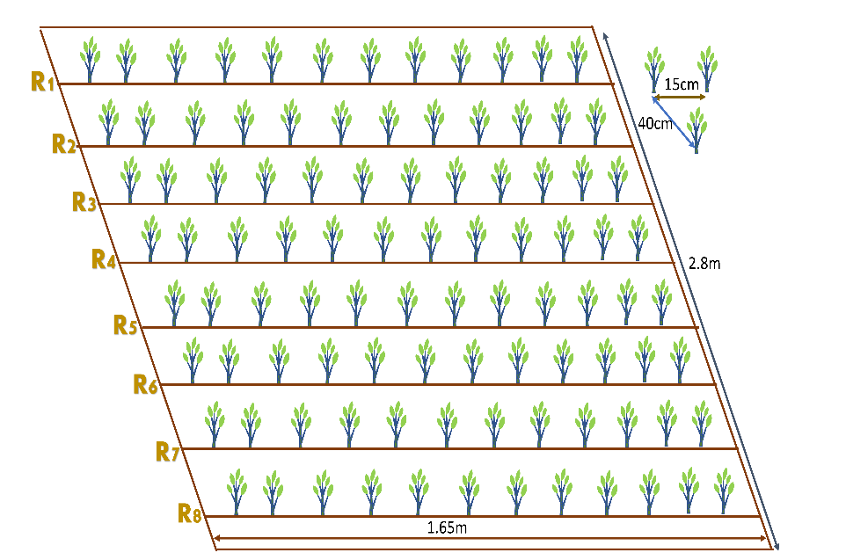

Figure 1 Representation of the Experimental demo plot and GIS map of the Research site

* 1. **Soil Properties and Observed traits**

Based on the soil data of the experiment site, the soil is sandy loam with an acidic pH of 5.52. The soil has medium organic matter content (3.42%), medium total nitrogen content (0.20%), medium total phosphorous content (10.5 ppm), and low total potassium content (5.5 ppm) Table 1.

Table 1 Methods for examining soil properties at the research site.

|  |  |  |  |
| --- | --- | --- | --- |
| S.N | Soil Property | Value/Rating | Method of Extraction |
| 1 | Sand% | 49.3 | The textural triangle of USDA |
| 2 | Slit% | 34.9 | The textural triangle of USDA |
| 3 | Clay% | 15.8 | The textural triangle of USDA |
| 4 | Textural Class | Sandy Loam | Determined by Marshall’s triangular coordinates by USDA system |
| 5 | PH | 5.52(Acidic Nature) | Digital pH Meter |
| 6 | Organic Carbon% | 3.201 | 58% of OM = Organic Carbon |
| 7 | Organic Matter | 3.42(medium) | (1-S/B)0.6810=3.42 because this study has 11.6 and 23.4 value of S and B. (Walkley and Black method) |
| 8 | Total N% | 0.20(Medium) | Micro-K-Jeldal Method |
| 9 | Total Phosphorous | 10.5 ppm(medium) | Modified Olsen's Bicarbonate Method |
| 10 | Total Potassium | 5.5ppm(low) | Flame photometer method |

* 1. **Meteorological features of the study site**

The weather parameters were recorded at the weather station of the National Maize Research Program (NMRP) in Rampur, Nepal, 500 meters away from the research station. The weather pattern for the mung bean cultivation season is given **Figure 2**.

**Figure 2 Evaluating Meteorological Data of Research Stations from Weather Stations**

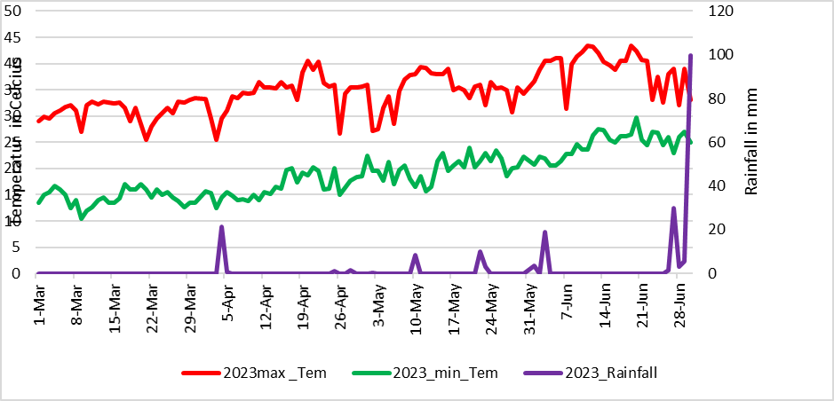

* 1. **Description of Phytohormones and Stickers and its Application.**

Enhancing Mung-Bean Growth and Yield through Foliar Spray of 50 mg/l IAA or NAA + 50 mg/l GA3 is the most recommended rate for sandy loam soil described by[15][10]. In this study, the utilization of phytohormones was carried out using this standardized approach. Specifically, Gibberellic Acid (GA3), Gib Max, sourced from Vee Aar Industries in West Bengal, India, with a 20% active ingredient (20g AI/100g powder), was applied at a concentration of 50 mg/L. Alpha Naphthaleneacetic Acid (NAA), Plano-fix, produced by Bayer Crops Science Limited in Mohali, Punjab, was applied using a battery-powered knapsack sprayer at the same concentration level (50 mg/L) in a 4.5% SL formulation. The application rate involved delivering half of the prescribed dosage of phytohormones via foliar spray 30 days after sowing, and then applying the remaining half during flowering, which typically occurs on day 54 post-sowing (DAS). 1,000 liters of water per hectare (equivalent to an area of 10,000 square meters) were used as solvents for these applications. Gorkha Sticker more, produced by Gorkha Agrochemical Pvt. Ltd., was added at a concentration of 0.5 ml/L to enhance phytohormone efficiency, completing this process, which was carried out only in the evenings.

* 1. **Multiple Traits Correlation and Regression analysis with Yield** 
     1. **Pearson correlation coefficient (r) Model**

The correlation coefficient, denoted as 'r,' quantifies the strength and direction of the linear relationship between two variables. It falls within the range of -1 to 1, with a value of 0 signifying the absence of a linear relationship. The following equation is employed for the correlation analysis of Mung-bean descriptors.

Where, and are individual data points and and are the means of ***X*** and ***Y***, respectively.

* 1. **Yield Calculation Model**

The grain yield per hectare for each genotype was calculated from the net plot yield, taking into account the moisture content of the grain. The moisture content of plots was measured using an automated moisture meter, and the final grain yield was adjusted to a moisture level of 10% using the following formula[16].

The moisture content (MC) is expressed as a percentage of the grain's weight. The straw yield was determined by subtracting the grain yield from the total biological yield (measured in kilograms per hectare). After completely sun-drying the harvested produce, the weight of grain and straw from each plot was recorded separately using a spring balance, and the measurements were noted in kilograms per plot. Subsequently, the per-plot biological yield was converted to kilograms per hectare. The collective yield of all plant materials is referred to as the biological yield, and the ratio of grain yield to biological yield is known as the harvest index, as defined by[17].

* + 1. **Genotype analysis by mixed-effect models**

Analysis of genotypes in single experiments using mixed-effect models with estimation of genetic parameters.

Where,   is the response variable of the ith  genotype in the *j*th block/replications; *m* is the grand mean (fixed);  is the effect of the *i*th genotype (assumed to be random); is the effect of the *j*th replicate (assumed to be fixed); and  is the random error. the BLUP model is used to estimate the genetic values of the genotypes for each trait in multi-trait genotype-ideotype distance index calculation. The multi-trait genotype-ideotype distance index is a method used to select genotypes in plant breeding programs based on multiple traits, and it is calculated as the Euclidean distance between the scores of the genotypes and the ideal genotypes.

* + 1. **Multi-Trait Genotype-Ideotype Distance Index (MTGID)**

Multivariate data in biological experiments are important for better treatment recommendations or genotype selection. Classical linear multi-trait selection indexes may not be effective due to multicollinearity and arbitrary weighting coefficients. A new approach called the MGIDI uses distance between genotypes/treatments and an ideotype to select unique, easy-to-interpret options without these issues. This concept is used in plant breeding and can improve the efficiency of selecting for multiple traits[18].

Where **=** index of multi-trait genotype-ideotype distance for the ith genotype. represents the score assigned to a given genotype in relation to a specific factor, denoted by "i" for the ith genotype and "j" for the jth factor. The variables g and f correspond to the total number of genotypes and factors included in this analysis, is the **jth** score of the ideotype. The genotype exhibiting the lowest MGIDI is more proximate to the ideotype and, consequently, is expected to showcase desirable values for all scrutinized traits.

The relative contribution of each factor to the MGIDI index for each genotype can be used to identify the strengths and weaknesses of those genotypes.

* + 1. **FA (Factor analysis) -BLUP(Best Linear Unbiased Prediction) Index Calculation**

1. **Rescaling the Traits**

Consider Xij as a table consisting of i rows representing genotypes or treatments, and j columns representing traits. To obtain the rescaled value for the ith row and jth column (rXij), use the following formula:

,………………………………………..

Where and represent the updated maximum and minimum values for trait j following the rescaling process**,** and represent the uppermost and lowermost limits of trait j, respectively. Meanwhile, is indicative of the initial value for the jth trait belonging to the ith genotype. To achieve negative gains in desired traits, it is recommended to utilize the values of = 0 and = 100. For desirable traits, the maximum value of set to 100 while the minimum value of is set to 0 in the re-scaled two-way table (rXij). This leads to each column exhibiting a range spanning from 0 to 100, which considers the intended direction of selection (either increase or decrease) and maintains the original correlation structure of the variable.

1. **Factor Analysis**

A statistical technique known as the factor analysis model is used to express variation among connected, observable variables in terms of a possibly smaller set of unobserved variables known as factors. The following formula can be used to express the factor analysis model:

X = μ + LF + ε

Factor analysis identifies underlying factors that explain correlations among observed variables. X is the vector of measurements, μ is the vector of means, L is a matrix of loadings, F is a vector of common factors, and ε is the vector of unique factors. Eigenvalues and eigenvectors are obtained from the correlation matrix of rXij. Initial loadings are based on eigenvalues higher than one. Varimax rotation criteria are used for analytic rotation and estimation of final loadings. Scores are obtained accordingly.

The matrix F contains the scores for factorial analysis, while Z is a matrix of standardized means that have been rescaled. A represents canonical loadings in a matrix with p rows and f columns, and R is a correlation matrix between traits with dimensions p by p. The variables g, f, and p denote the number of genotypes or rows analyzed, factors retained during analysis, and traits studied respectively.

1. **Spatial Probability Calculation:**

Genotype-Ideotype distance is used to rank genotypes by estimating spatial probability. The FAI-BLUP index uses a Markov chain to calculate the probability of transitioning between states based on genotype distance and an ideotype. Closer states have a higher probability of transitioning. This index identifies underlying factors for balanced genetic gain and easy selection process. The subsequent mathematical formula is employed to compute the likelihood of spatial occurrence:

In which Pij is the likelihood that the ith genotype (i = 1, 2,...,. n) will resemble the jth ideotype (j = 1, 2,..., m); and dij is the distance between the ith genotype and the jth ideotype based on the standardized mean Euclidean distance.

* 1. **Mean performances Evaluation**

The mean performance of 16 mung genotypes and promising cultivars has been assessed based on 16 agro-morphological descriptors during post-fertility evaluations. To determine the significance of differences among these genotypes, a Duncan Mean Comparison test, which is an adaptation of the Newman-Keuls method, has been employed. It's important to note that Duncan's test does not effectively control the family-wise error rate at the specified alpha level(**https://search.r-project.org/CRAN/refmans/agricolae/html/duncan.test.html**). It appears more powerful than some other post hoc tests, but this increased power stems from its inability to control the error rate adequately. The Experiment wise error rate is determined by taking 1 - (1 - α)(a-1), where "a" is the number of means being compared and "alpha" denotes the error rate per comparison. In comparison to the Least Significant Difference (LSD) method, Duncan's method is just slightly more cautious. The default alpha level is typically set to 0.05(**Hsu, J.; 1996).**

* 1. **Statistical analysis**

An analysis of variance (ANOVA) was conducted to assess the impact of foliar application of phytohormones on the yield and performance of promising mungbean cultivars. Data entry was performed using Excel, and the analysis was carried out using R version 4.3.1 (dated 2023-06-16). Subsequently, regression and correlation analyses were conducted to examine the relationships among the chosen parameters at significance levels of 1% and 5%. For mean separation, Duncan's Multiple Range Test (DMRT) was employed. Various R packages were used for specific purposes, such as "agricolae" for mean separation (“gvlma” Normal Distribution Testing, and "metan" for calculating Pearson correlation coefficients and multi-trait genotype-ideotype distance indices for Crop Ideotype Modeling. The "gamem" function in the R package "metan" was used for genotype analysis in single experiments, employing a randomized complete block design by default. Additionally, "ggplot",”circlize” and "reshape" packages were utilized for visualizing correlation coefficients and other Graphics, To evaluate treatment effects, the "F" test was employed.

1. **Results**
   1. **Analysis of Variance (ANOVA) for Mean Performance Evaluation and Comparison for Fertility and Yield Associated Traits**

Foliar application of plant growth promoters (PGPs) significantly reduced flower drops in mung bean (Vigna radiata) (p ≤ 0.001, 0.01, or 0.05). A combination of 25 mg/L alpha-naphthaleneacetic acid (NAA) and 25 mg/L gibberellic acid (GA3) notably decreased flower drops 12 hours post-application, primarily due to a decrease in flower shedding. The cultivar Pratigya exhibited the highest recorded number of flower drops (mean = 8), followed by Pant mung 2, while the genotype NM54 displayed the least flower drops, likely due to its less responsive flowering habit. The genotype VC6368 (46-40-3) demonstrated the highest number of pods per cluster, and the difference in flower drops before and after hormone application was 5, indicating a significant (p < 0.01) reduction in flower shedding. This result suggests improved pollination and enhanced grain set, resulting in an average of 8 grain per pod. The ideal genotypes VC6370A and CN95 also exhibited effective control over flower drops, resulting in longer pods, more pods per cluster, and larger grains. VC6370A displayed the highest grain diameter (3.92 mm as measured by a digital Vernier caliper), closely followed by KPS1, while CN95 had an average grain diameter of 3.62 mm. The genotypes displayed a low CV (9.90%) for plant flower drops after hormone application, indicating that various genotypes may share similar sensitivities to PGPs. A 5% decrease in the CV for sample plant flower drops after hormone application further indicates that the hormone treatment effectively reduced variability in the number of flowers drops *Table 2*. This reduction in variability can be attributed to the promotion of flower bud growth and development, a decrease in the number of aborted flower buds, and an increase in the resistance of flower buds to environmental stressors. Ultimately, this reduced variability is associated with more consistent grain yields in mung bean cultivation.

Table 2 Representation of Flowering and Post-Flowering Associated Traits with Standard Formulation of Two Phytohormones

|  |  |  |  |  |  |
| --- | --- | --- | --- | --- | --- |
| Genotypes | SPFDBAH ±SD | SPFDAAH± SD | Length of the Pod ± SD | Pod/Cluster ±SD | Diameter of Grain ± SD |
| VC6368(46-40-3) | 5.37±0.77 | 0.75±0.07 | 8.62 ± 1.09 | **10.5a** ± 0.71 | 3.60 ± 0.44 |
| **NM-54** | 4.13±0.70 | 0.733±0.07 | 8.75 ± 0.97 | 4.93 ± 0.37 | 3.64 ± 0.16 |
| VC6370A | 5.86±0.59 | 1.26**ab**± 0.05 | 8.14 ±1.33 | 6.66± 0.98 | **3.92b** ± 0.25 |
| VC1973A(SC) | 6.13±0.56 | 0.80±0.06 | 7.99 ± 0.64 | 7.60± 0.64 | 4.06 ± 0.41 |
| VC6173C | 5.20 ±0.99 | 0.53±0.05 | 6.98± 1.42 | 6.71± 0.55 | 3.75 ± 0.39 |
| CN95 | 6.40 ±0.86 | 0.80±0.08 | **9.20a** ± 0.81 | 7.00 ± 0.34 | 3.62± 0.33 |
| VC6848 | 5.33±0.74 | 0.86±0.07 | 8.16 ± 1.36 | 5.46 ±0.55 | 3.86 ± 0.15 |
| PRATIGYA | **8.13**a ±0.91 | 0.73± 0.07 | **9.02**ab±0.84 | 5.73 ± 0.45 | 3.53 ±0.23 |
| KPS-1 | 7.60 ±0.91 | 0.53±0.09 | 7.45 ± 0.90 | 2.8 ±0.73 | **3.87**± 0.40 |
| VC3890A | 5.06 ±0.74 | 0.53±0.07 | 8.34 ±0.93 | 4.20 ± 0.11 | 3.71± 0.29 |
| VC6173A | 7.42 ±0.99 | 0.92±0.09 | 8.02 ± 0.88 | 6.71 ± 0.55 | 3.75± 0.28 |
| SAMRAT | 6.53 ±0.63 | 0.46± 0.06 | 7.43 ± 1.19 | 3.60 ± 0.45 | 3.67± 0.32 |
| PANT MUNG 2 | 7.60 ±0.91 | 0.60±0.09 | 8.16 ± 0.75 | 4.20 ± 0.16 | 3.59 ±0.28 |
| MN92 | 7.466±0.75 | 1.0±0.07 | 8.84 ± 0.67 | 5.26 ± 0.90 | 3.73 ±0.18 |
| VC6369 | 6.66 ±0.50 | 0.40±0.05 | 8.35 ± 1.46 | 5.80± 0.24 | 3.79 ±0.28 |
| VC3960A-88 | **7.20** ±1.18 | 1.53**a**±0.18 | 9.04 ±1.146 | 7.80± 0.93 | **3.96a**± 0.17 |
| LSD(0.05) | 0.33 | 0.094 | 0.135 | 0.675 | 0.03 |
| SEm | 0.17 | 0.191 | 0.074 | 0.353 | 0.02 |
| F-prob | <0.001 | <0.01 | <0.001 | <0.05 | <0.001 |
| CV% | 14.96 | 9.90 | 12.63 | 9.82 | 8.162 |

Several genotypes, such as VC6370A, VC1973A-(SC), and VC6173A, exhibit larger grain size, suggesting their potential for increased nutritional value and yield. VC6370A has the largest grain area (21.96 mm²), followed by VC1973A-(SC), which is of comparable grain size to VC6173A and VC6173C (20.98±2.24 mm²). Larger grain size promotes robust and vigorous seeds germination. CN95 has the highest grain count per pod (10 grains), while MN95 has the highest clusters per plant but the fewest grains per pod (7). The remarkably low p-values (F-prob <0.001) for all measured traits indicate that there are statistically significant differences among the genotypes for all of these characteristics. This highlights the importance of genotype selection in mung bean breeding programs Table 3.

Table 3 Representation of Grain Characteristics and Variability Among Mung Bean Genotypes

|  |  |  |  |  |
| --- | --- | --- | --- | --- |
| Genotypes | Length of Grain± SD | Area of Grain± SD | Grains/Pod ± SD | Clusters/Plant± SD |
| VC6368(46-40-3) | 5.19± 0.39 | 18.68±2.66 | 8.68± 0.24 | 7.31±0.092 |
| NM-54 | 5.19 ±0.39 | 17.81±1.76 | 6.20±0.74 | 6.60±0.32 |
| VC6370A | 5.58± 0.62 | **21.96a±3.27** | **8.96b**± 0.94 | 8.00±0.92 |
| VC1973A-(SC) | 5.28± 0.64 | **21.50±3.85** | 7.93 ± 0.25 | 9.00±0.58 |
| VC6173C | **5.60a**± 0.40 | **20.98**±2.24 | 8.20± 0.95 | 5.60±0.50 |
| CN95 | 4.92 ±0.45 | 17.88±2.51 | **10.46a**± 0.16 | **8.20**±0.8 |
| VC6848 | 5.22 ±0.50 | 20.16±1.84 | 8.53±0.58 | 6.80±0.1 |
| PRATIGYA | 5.07± 0.37 | 17.96±1.76 | 8.93± 0.21 | 7.00±0.4 |
| KPS-1 | 4.86 ±0.48 | 18.08±2.59 | 5.13± 0.81 | 4.13±0.47 |
| VC3890A | 5.07± 0.45 | 18.85±2.20 | 8.66± 0.28 | 5.60±0.22 |
| VC6173A | **5.60a**± 0.64 | **20.98**±3.12 | 7.42± 0.60 | 9.21±0.77 |
| SAMRAT | 5.43± 0.37 | 19.98±2.55 | 8.00± 0.53 | 4.80±0.89 |
| PANT MUNG 2 | 4.91 ±0.47 | 17.68±2.11 | 7.66±0.26 | 5.86±0.50 |
| MN92 | **5.59a**± 0.35 | **20.94**±2.14 | 4.40±0.01 | **9.20a**±1.00 |
| VC6369 | 5.17± 0.42 | 19.65±2.04 | 6.40±0.88 | 7.00±0.6 |
| VC3960A-88 | 5.37± 0.37 | 21.34±2.04 | **8.60**±1.20 | 7.40±1.18 |
| LSD(0.05) | 0.05 | 0.30 | 0.35 | 0.39 |
| SEm | 0.0339 | 0.18 | 0.20 | 1.03 |
| F-prob | <0.001 | <0.001 | <0.001 | <0.001 |
| CV% | 9.02 | 12.53 | 8.82 | 5.396 |

Among the diverse mung bean genotypes, several stand out with notable traits, showing promise for breeding and agricultural improvement. "VC6370A" and "VC3960A-88" demonstrate the potential for higher grain yields due to their higher 100-grain grain weights, which can enhance both yield and nutritional quality. "VC6368(46-40-3)" and "VC1973A(SC)" exhibit elevated straw yields, making them valuable for livestock feed and soil enrichment. Notably, "VC6370A" (3.04 ton/ha ±0.00) followed by CN95 (2.84 ton/ha) excel in grain yield, signifying its potential to boost agricultural productivity and food security. Additionally, "VC3960A-88" has an efficient harvesting index, indicating optimal resource utilization for grain production *Table 4*.

Table 4 Evaluation of Mung Bean Genotypes for Key Yield-Related Characteristics and Their Phytohormone Responsiveness

|  |  |  |  |  |  |
| --- | --- | --- | --- | --- | --- |
| Genotypes | 100 Grain grain weight± SD | Straw Yield/ha± SD | Biological Yield kg/Ha± SD | Harvesting Index± SD | Grain yield (Tons)/ha± SD |
| VC6368(46-40-3) | 5.15±0.0765 | 3197±0.00 | 5779.60±0.005 | 0.45 ±0.00 | 2.58±0.00 |
| NM-54 | 5.41±0.00 | 3154±0.00 | 5678.20 ±0.005 | 0.44 ±0.00 | 2.52±0.00 |
| VC6370A | **5.88a**±0.00 | 3126±0.00 | 5610.36±0.005 | 0.44 ±0.00 | **3.04a** ±0.00 |
| VC1973A(SC) | 4.96±0.00 | **3207±**0.00 | 5920.08±0.005 | 0.46 ±0.00 | 2.71±0.00 |
| VC6173C | 5.39±0.00 | 3056±0.00 | 5035.12 ±0.005 | 0.41 ±0.00 | 2.085±0.00 |
| CN95 | 5.26±0.00 | 3293±0.00 | 6133.08 ±0.005 | **0.48 a** ±0.00 | **2.84****ab** ±0.00 |
| VC6848 | 5.80±0.00 | 3013±0.00 | 5385.60 ±0.006 | 0.44 ±0.00 | 2.37±0.00 |
| PRATIGYA | 5.46±0.00 | 3012±0.00 | 5322.534±0.005 | 0.43 ±0.00 | 2.31±0.00 |
| KPS-1 | 6.66±0.00 | 2360±0.00 | 3494.18 ±0.005 | 0.32 ±0.00 | 1.134± 0.00 |
| VC3890A | 6.21±0.00 | 3120±0.00 | 5578.330±0.005 | 0.44 ±0.00 | 2.45±0.00 |
| VC6173A | 4.87±0.00 | 3056±0.00 | 5545.172±0.005 | 0.45 ±0.00 | 2.48±0.00 |
| SAMRAT | 5.40±0.00 | 2120±0.00 | 3378.120±0.005 | 0.37 ±0.00 | 1.25±0.00 |
| PANT MUNG 2 | 4.75±0.00 | 2930±0.00 | 5178.700±0.005 | 0.43 ±0.00 | 2.24±0.00 |
| MN92 | 4.85±0.00 | 3186±0.00 | 5684.88 ±0.005 | 0.44±0.00 | 2.49±0.00 |
| VC6369 | 5.36±0.00 | 2993±0.00 | 5805.60 ±0.005 | **0.46b**±0.00 | 2.81±0.00 |
| VC3960A-88 | 5.07±0.00 | 3267±0.00 | **6316.657** ± 1729.933 | 0.46**b** ±0.00 | **2.83ab**±0.072 |
| LSD(0.05) | 0.002 | 1.24 | 54.97426 | 0.0024 | 0.054 |
| SEm | 0.032 | 19.97 | 111.58 | 0.003 | 0.042 |
| F-prob | <0.001 | <0.001 | <0.001 | <0.001 | <0.001 |
| CV% | 0.36 | 0.32 | 8.05 | 4.47 | 3.06 |

* 1. **Analysis of Correlation Among Post-Fertilization Quantitative Traits**

The correlation matrix in (supplementary table2) and Figure 3 shows the pairwise relationships between variables, computed using Pearson's correlation with listwise deletion for missing data. Each cell contains a correlation coefficient, which quantifies the strength and direction of the linear relationship between two variables, assessed for statistical significance at the 0.05 or 0.001 level. Several notable correlations were observed. The highest positive significant correlations were between number of pods per cluster and grain yield per hectare (r = 0.96, p < 0.001), followed by grain yield per hectare and harvesting index (r = 0.95, p < 0.001), and straw yield and harvesting index (r = 0.94, p < 0.001).Number of sample plant flower drops before and after application of the hormone was negatively correlated with number of pod clusters (r = -0.65, p < 0.05 and r = -0.65, p < 0.001), respectively), especially after 12 hours. Diameter of grain was positively correlated with area of grain (r = 0.94, p < 0.001). Number of grains per pod was positively correlated with grain yield per hectare (r = 0.67, p < 0.05). Additionally, 100-grain grain weight was negatively correlated with straw yield per hectare (r = -0.80, p < 0.001) and biological yield per hectare (r = -0.63, p < 0.05).

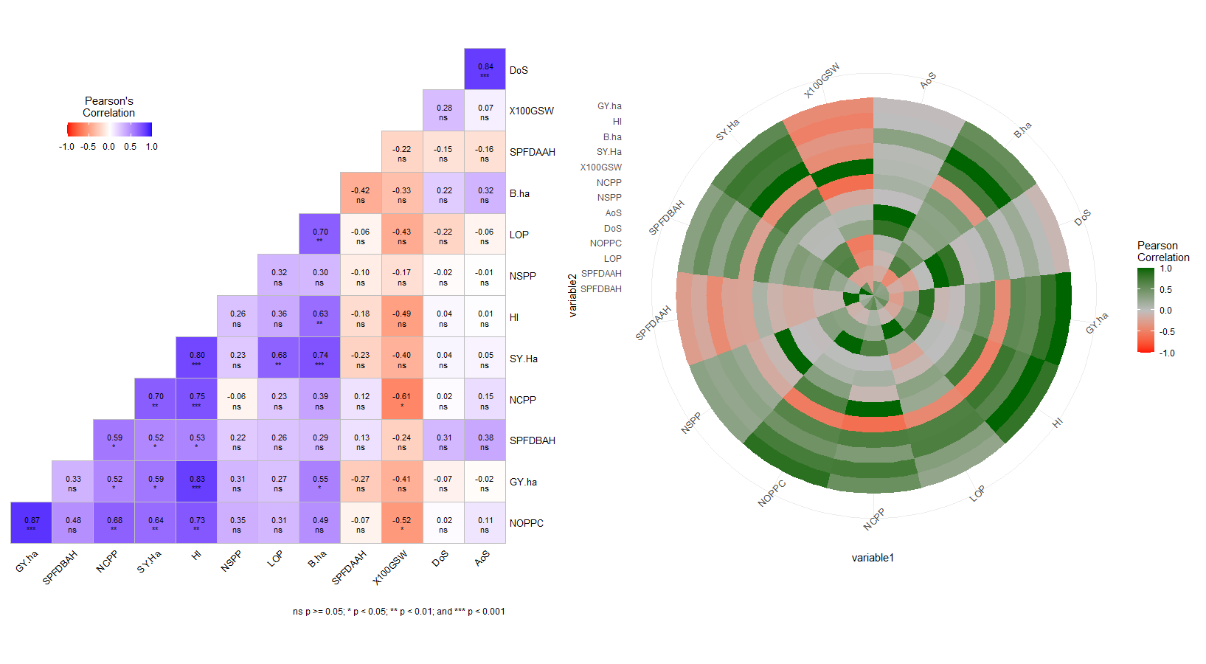

Figure 3 Correlation Matrix Heat Map of the Post Fertility-Associated Traits of the Mung Bean Genotypes and Promising Cultivars.

* 1. **Identification of Ideal Mung bean Genotypes using Multi-Trait Stability Index (MTSI)**

Two genotypes, VC6370A followed by CN95, have been identified as the optimal genetic strains for mung-bean cultivation in Chitwan, based on a comprehensive analysis of key attributes highlighted in . These genotypes are considered top-notch in terms of both stability, adaptability and overall performance among the varieties investigated. The average values of these chosen genotypes (Xs) were found to be higher than the original mean (Xo), which encompassed all 16 mung-bean genotypes, for all examined variables except SPFDAAH (Sample Plant flower drops after application of the hormone) and grains per pod (NSPP). The selection difference (SD) was positive for all variables, except for NSPP and SPFDAAH. The heritability (h2) ranged from 0.157 for NOPPC to a perfect 1 for HI and X100GSW (as indicated in Table 6) followed by grain and biological yield/ha. Additionally, the selection gain (SG) was positive for all studied parameters except NSPP and SPFDAAH. The most substantial positive SG was observed at 27.113% for B.ha, while NOPPC showed the lowest SG value at 0.120%. Conversely, the negative SG ranged from -0.144% for NSPP to -0.683% for SPFDAAH.

* + 1. **Contribution factor rank of the selected genotypes**

For the traits FA1, FA3, and FA4, FA7 CN95 ranked first, while FA2, FA6(Pre fertility Traits) and FA9 ranked first for VC6370A across all analyzed attributes *Table 5*. Consequently, the selected genotypes exhibit higher genotypic stability compared to the original population, which is a crucial aspect in genetic breeding efforts.

Table 5 Representation of the contribution factor rank of the selected genotypes. Exclusion of Genotypes FA5, FA6, FA7, and FA8 Due to Their Contribution to Pre-Fertilization Traits (supp file)

|  |  |  |  |  |  |  |  |  |
| --- | --- | --- | --- | --- | --- | --- | --- | --- |
| **FA1** | **FA2** | **FA3** | **FA4** | **FA5** | **FA6** | **FA7** | **FA8** | **FA9** |
| CN95 | VC6370A | CN95 | CN95 | CN95 | VC6370A | CN95 | VC6370A | VC6370A |
| VC6370A | CN95 | VC6370A | VC6370A | VC6370A | CN95 | VC6370A | CN95 | CN95 |

Table 6 Summary of estimation of the genetic parameters Based on Multi-Trait Selection Index (MTSI) for Fourteen Post-Fertility-Associated Traits Assessed in Sixteen Mung Bean Germplasms

|  |  |  |  |  |  |  |  |  |  |
| --- | --- | --- | --- | --- | --- | --- | --- | --- | --- |
| **Variables** | **Factor** | **Xo** | **Xs** | **SD** | **SD%** | **h2** | **SG** | **SG%** | **sense** |
| SPFDBAH | FA1 | 0.779 | 0.930 | 0.150 | 19.299 | 0.226 | -0.034 | -4.353 | **decrease** |
| LOP | FA1 | 7.303 | 7.479 | 0.176 | 2.416 | 0.357 | 0.063 | 0.862 | increase |
| NOPPC | FA1 | 5.750 | 5.794 | 0.044 | 0.765 | **0.157** | 0.007 | 0.120 | increase |
| NCPP | FA1 | 2.283 | 2.467 | 0.183 | 8.027 | 0.361 | 0.066 | 2.901 | increase |
| SY.Ha | FA1 | 2999.625 | 3210.077 | 210.452 | 7.016 | 1.000 | 210.386 | 7.014 | increase |
| B.ha | FA1 | 10406.339 | 13229.841 | 2823.502 | 27.133 | **0.999** | 2821.425 | 27.113 | increase |
| HI | FA1 | 0.697 | 0.750 | 0.052 | 7.519 | 1.000 | 0.052 | 7.516 | increase |
| GY.ha | FA1 | 7.407 | 10.020 | 2.613 | 35.280 | **0.999** | 2.611 | 35.253 | increase |
| DoS | FA2 | 3.738 | 3.767 | 0.030 | 0.790 | 0.424 | 0.013 | 0.335 | increase |
| LoS | FA2 | 5.189 | 5.241 | 0.052 | 0.997 | 0.447 | 0.023 | 0.446 | increase |
| AoS | FA2 | 19.428 | 19.856 | 0.428 | 2.203 | 0.536 | 0.229 | 1.181 | increase |
| NSPP | FA3 | 6.500 > | 6.477 | -0.023 | -0.349 | 0.413 | -0.009 | -0.144 | increase |
| X100GSW | FA4 | 5.407 | 5.571 | 0.165 | 3.044 | 1.000 | 0.164 | 3.042 | increase |
| SPFDAAH | FA9 | 3.188 > | 3.107 | -0.080 | -2.522 | 0.271 | -0.022 | -0.683 | **decrease** |
| Xo: overall mean of genotypes; Xs: mean of the selected genotypes; SD: selection differential; SG: selection gain  or impact; h2: heritability; SPFDBAH & SPFDAAH: sample plant flower drops before and after application of the  hormone; LOP: Length of pod; NOPPC: pods/cluster; SY.ha: straw yield/ha; B.ha: Biological yield/ha; HI:harvest index; DoS,AoS& LoS: Diameter, area and Length of grain; NSPP: grain per pods; X100GSW:100 grain weight. | | | | | | | | | |

communalities and uniqueness indicate the degree to which the post-fertility associated variables of mung bean share common variance and unique variance. communalities for the post-fertility associated variables of mung bean would indicate how much of the variance in each variable is explained by the underlying factors. uniqueness indicates the degree to which an observed variable has unique variance that is not shared with other variables in the dataset. The uniqueness for the post-fertility associated variables of mung bean would indicate how much of the variance in each variable is not explained by the underlying factors. Highest value (0.986) of communalities is expressed by biological yield/ha followed by two traits (0.981) yield/ha & harvesting index. The highest value of uniqueness is indicated by SPFDAAH followed by diameter of grain (DoS) is shown in given *Table 7*

Table 7 Factorial Loadings After Varimax Rotation, Communalities, and Uniqueness for Post-Fertility Associated Variables of mung bean.

|  |  |  |  |  |  |  |  |
| --- | --- | --- | --- | --- | --- | --- | --- |
| **Variables** | **FA1** | **FA2** | **FA3** | **FA4** | **FA9** | **Comm** | **Uniq(1-Co)** |
| SPFDBAH | 0.558 | -0.397 | 0.038 | 0.058 | 0.302 | 0.886 | 0.114 |
| SPFDAAH | -0.060 | 0.166 | -0.234 | 0.014 | 0.793 | 0.843 | 0.157 |
| LOP | 0.639 | 0.197 | -0.249 | 0.247 | 0.118 | 0.944 | 0.056 |
| NOPPC | 0.747 | -0.116 | -0.265 | 0.308 | -0.228 | 0.885 | 0.115 |
| DoS | 0.126 | -0.749 | 0.106 | -0.291 | 0.071 | 0.857 | 0.143 |
| LoS | -0.053 | -0.849 | 0.084 | 0.286 | -0.093 | 0.868 | 0.132 |
| AoS | 0.057 | -0.926 | 0.122 | 0.036 | -0.010 | 0.921 | 0.079 |
| NSPP | 0.200 | 0.000 | -0.611 | 0.347 | -0.240 | 0.866 | 0.134 |
| NCPP | 0.755 | -0.196 | 0.041 | 0.363 | 0.106 | 0.888 | 0.112 |
| X100GSW | -0.432 | -0.180 | 0.000 | -0.701 | -0.184 | 0.887 | 0.113 |
| SY.Ha | 0.818 | -0.127 | -0.007 | 0.190 | -0.096 | 0.950 | 0.050 |
| B.ha | 0.971 | 0.042 | -0.021 | 0.038 | -0.133 | **0.986** | 0.014 |
| HI | 0.961 | 0.073 | 0.025 | 0.101 | -0.129 | 0.981 | 0.019 |
| GY.ha | 0.966 | 0.061 | -0.022 | 0.018 | -0.134 | 0.981 | 0.019 |
| SPFDBAH& SPFDAAH: sample plant flower drops before and after application of the hormone; LOP:length of pod; NOPPC: no of pod per cluster; SY.ha: straw yield/ha; B.ha: Biological yield/ha; HI:harvest index; DoS,AoS& LoS: Diameter, area and Length of grain; NSPP: no of grain per pod; X100GSW:100 grain grain weight. | | | | | | | |

* + 1. **Assessment of Genotype Strengths and Weaknesses for Post Fertility Associated Traits.**

The factors that make up the MGIDI are divided into two categories: those that contribute more and those that contribute less. In the graphical representation, factors that contribute more to the MGIDI are closer to the center, while those that contribute less are closer to the edge. A dashed line shows what the MGIDI would be if all factors contributed equally *Figure 4*. The radar plot analysis revealed that FA1, which is related to grain yield, Biological yield and harvesting index, is the least important factor in the MGIDI of genotypes VC6368 (46-40-3), VC1973A(SC), and CN95. This indicates that these are the most productive genotypes among the selected ones. On the other hand, FA1 is more important in the MGIDI of KPS-1 and VC6173C, which suggests that these genotypes are less productive. This interpretation applies to other factors as well. Genotypes VC1973A(SC), CN95, VC6368 (46-40-3), VC3960A-88, and VC6173A have strengths associated with FA1 traits, which include grain yield and harvesting index-related characteristics. As all traits in FA1 benefit from positive gains, these genotypes should have high values for all three: LOP (Length of Pod), NOPPC (Pods per Cluster), and NCPP (Clusters per Plant)

FA2 contributing very little to the MGIDI in VC6370A and MN92 suggests that these genotypes have high values for DoS (Diameter of Grain), LoS (Length of Grain), and AoS (Area of Grain) compared to NM-54, where FA2 contributes more. The cultivar 'SAMRAT' has the highest contribution to FA3, indicating that it has a greater number of grains per pod than VC6370A. VC6173C has the highest contribution to FA4, which pertains to the MGIDI index, due to its lower 100-grain grain weight compared to CN95. Lastly, FA9 exhibits the smallest contributions for VC6370A and CN95, signifying that these genotypes drop fewer flowers after hormone application within 24 hours. This shows that the flowers have finished blooming and have been pollinated. *Table 6*presents data related to the traits of the selected genotypes in comparison to the overall mean traits of all genotypes. This comprehensive approach helps to identify the best genotypes that can be used to breed guar varieties with high grain yield and other desirable characteristics.

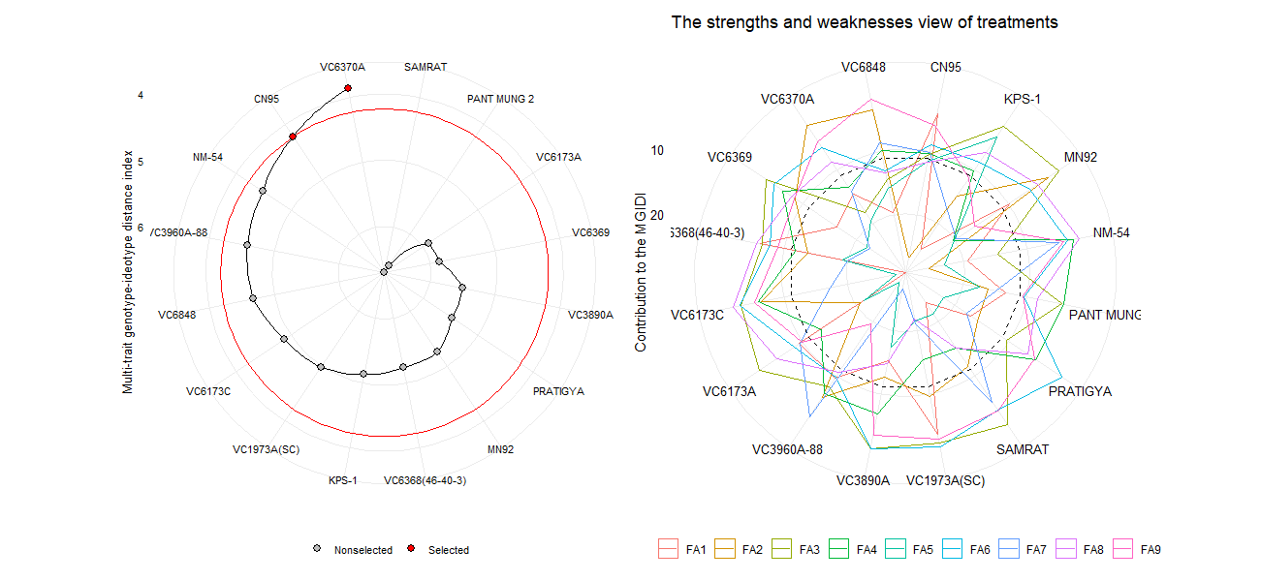

Figure 4 Graphics depicting the selected(A) ideal and non-selected genotypes and(B) the strength and weakness of MGIDI contributions to factor loading.

A

B

1. **Discussion**

In Nepal, where more than three-quarters of mung-bean is grown in rainfed conditions, the Multi Trait Stability Index (MTSI) is a valuable tool for identifying mung-bean genotypes that are resistant to water stress. These genotypes can then be used in breeding programs to develop superior mung-bean varieties for rainfed conditions[19]. selected genotype VC6370A had a higher genotypic rank than CN95 for FA2, FA6, FA8, and FA9, which are associated with flowering and post-flowering traits. CN95 had a higher genotypic rank than VC6370A for FA1, FA3, FA4, FA5, and FA7. This demonstrates the high reliability of the genotype ranking, as the same protocols were used to select Tahiti acid lime genotypes using Bayesian inference[20]. The Multi Trait Stability Index (MTSI) analysis revealed that biological yield, grain yield, and harvesting index were the most stable traits, with factorial loadings of 0.971, 0.966, and 0.961, respectively. The least stable trait was diameter of grain, with a factorial loading of 0.12. Sample plant flower drops after application of hormone at an interval of 12 hours had a negative factorial loading of -0.06, indicating that it was unstable across environments. The highest factorial loading for factor 1 was 0.197 for length of the pod, and null for number of grains per pod. All yield-related traits, such as length of the pod, number of pods per cluster, number of clusters per plant, straw yield per ha, harvesting index, and grain yield, were distributed on factor 1. Factor 2 consisted of diameter, length, and area of grain, FA4, and FA9, which consisted of single traits such as 100 grain grain weight and sample plant flower drops after application of hormone. MTSI analysis suggests that breeders have concentrated on developing genotypes with desired yield-related traits. However, all fertility-related traits, except for sample plant flower drops after application of hormone, need to be increased. Thus, Stable Genotypes have with improved morphological quantitative traits, such as clusters plant−1 , pods cluster−1 , grains pod−1 , branches plant−1 [7].A separate study of white Guinea yam genotypes found that the FAI-BLUP index technique could be used to identify genotypes that could be used as parents to breed new varieties with improved agronomic traits and end-product quality[21]**.** A multi-environment trial of rapegrain showed that the BLUP model could be used to select a single trait accurately. However, genotype recommendations based on a single trait, such as mean performance or stability, are incomplete and biased. Therefore, it is preferable to select genotypes based on multiple traits[22]. Thus, FAI-BLUP method is a statistical approach that uses structural equation modeling to rank genotypes based on their similarity to an ideal genotype, using multi-trait data without multicollinearity[23].

The present study investigated the impact of phytohormones applied at a standard rate on the flowering and post-flowering characteristics of mung bean genotypes within the rain-fed, subtropical climate of Chitwan, Nepal. The outcomes of this study revealed a significant and noteworthy influence of exogenously applied phytohormones on various key parameters. These parameters encompassed flower shedding, and post-flowering traits, such as the number of clusters per plant, number of pods per cluster, pod length, the number of grains per pod, grain dimensions, pod count, pod length, straw yield, harvest index, and overall mung bean genotype yield, as depicted in (*Table 2* **to** *Table 4***)**. The notable findings regarding the impact of phytohormones suggest that gibberellic acid (GA) may possess the capacity to intricately integrate with the flowering process. This integration appears to enable the fine-tuning of these responses, particularly when confronted with variable environmental factors in the field, such as fluctuations in moisture and temperature stress, as elucidated[24][25]. Similar outcomes were observed in a study where the combined foliar application of Indole-3-acetic acid (IAA) and Gibberellic acid (GA3), referred to as IAA2 + GA2, exhibited a notably robust impact on various yield attributes. This included a substantial increase of 66.0% in the number of pods, a remarkable 142.0% enhancement in pod weight, and a noteworthy boost of 106.5% in grain yield when compared to the control group[10]. In a separate investigation concerning soybean, the impact of 2,4-dichlorophenoxyacetic acid (2,4-DP) and Benzyl aminopurine (BAP) on pod set and grain yield during reproductive stages indicated a significant improvement in the 100-grain weight. Particularly, the application of 1 mM BAP resulted in a substantial increase to 22.3 g at the R1 stage[26]. Furthermore, an investigation into the pigeon pea species demonstrated that the foliar application of Naphthalene acetic acid (NAA) had a marked impact on reducing flower drop per plant and enhancing yield-attributing traits. Notably, the treatment with 80 ppm NAA exhibited superior efficacy in comparison to other treatments and the control group [27]. An additional study on mung beans revealed that foliar application of gibberellic acid GA3 at 200 ppm during the 30 and 60 days after sowing (DAS) had the potential to promote growth and enhance yield attributes and grain yield in mung beans[11]. In the context of green gram (Vigna radiata L.), a study investigated the impact of post-flowering management using plant growth regulators, with a particular focus on auxin and zeatin. Among the various treatments, the application of Nano-emulsion of NAA at 30 ppm demonstrated the most favorable results, manifesting in a higher number of mature pods, increased grain yield, greater grain weight, and a lower percentage of flower shedding [28]. A study centered on sesame (*Sesamum indicum L. cv*. Rama) evaluated the influence of plant growth regulators under moisture-stress conditions. Notably, the application of 200 ppm of these regulators yielded remarkable results in terms of growth, morpho-physiological characteristics, and grain yield [29]. These findings collectively underscore the significant influence of phytohormones and growth regulators on crop yield and associated attributes across various plant species, including mung beans, soybeans, pigeon peas, green gram, and sesame. This finding demonstrated a substantial degree of consistency with our original alternate hypothesis. To reinforce the effectiveness of phytohormone application in mung bean cultivation, additional research with an increased sample size and stricter environmental controls would be essential to recommend this study. Mung bean germplasm is highly diverse, and environmental factors can influence gene expression, so breeding has the potential to significantly improve yield. However, more research is needed to address study limitations, make SNP markers more accessible, and confirm water stress resistance under field conditions. Phytohormones can improve yield but are expensive and may have environmental impacts.

1. **CONCLUSION**

**Mung-bean breeding programs can improve yield by selecting for traits that are strongly correlated with yield, such as grains per pod, clusters per plant, grain dimensions, hundred grain weight, and harvesting index.** The analysis of variance indicated highly significant variations among the 16 genotypes for all the traits. The results also showed that the application of naphthalene acetic acid (NAA) and gibberellic acid (GA3) at 50 mg/L each significantly increased yield attributes in mung-bean, including total pods per plant, pod length, grains per pod, total grains per plant, and 100-grain weight. **This study found that these traits were also the most important for explaining the variation in yield among mung-bean genotypes.** Genotypes identified using the MTSI technique can be used as parents to breed new mung-bean varieties with desirable agronomic traits. Two genotypes, VC1973A and CN95, were selected as the most stable and high yielding(2.8tons/ha) among the 16 genotypes studied. The best-performing genotypes, identified by their high genotypic values based on the multi-trait selection index, should be further evaluated in mega environment conditions to assess their suitability for commercial release.

**AUTHOR CONTRIBUTIONS**

**Bikas Basnet:** Conceptualization, Investigation; methodology; formal analysis; writing—original proof reading of final draft, Writing—review and editing; visualization; software, Funding acquisition.

**Umisha Upreti:** Investigation; Writing—review and editing.

Krishna Prasad Thapaliya: Review and editing.

**ACKNOWLEDGEMENTS**

First author is thankful to Agriculture and Forestry University for providing land for this study and Grain Legumes Research Program, Khajura, Bake, Nepal for Providing the Germplasm.

**Funding Statement**

No any fund is received on this study.

**CONFLICT OF INTEREST STATEMENT**

No conflict of interest exists.

**DATA AVAILABILITY STATEMENT**

The data will be available on request.

References

[1] Y. J. Kang *et al.*, “Genome sequence of mungbean and insights into evolution within Vigna species,” *Nat. Commun.*, vol. 5, 2014, doi: 10.1038/ncomms6443.

[2] C. Liu *et al.*, “High-quality genome assembly and pan-genome studies facilitate genetic discovery in mung bean and its improvement,” *Plant Commun.*, vol. 3, no. 6, p. 100352, 2022, doi: 10.1016/j.xplc.2022.100352.

[3] K. Sandhu and A. Singh, “Strategies for the utilization of the USDA mung bean germplasm collection for breeding outcomes,” *Crop Sci.*, vol. 61, no. 1, pp. 422–442, 2021, doi: 10.1002/csc2.20322.

[4] “View of Mung bean proteins and peptides_ nutritional, functional and bioactive properties.pdf.” .

[5] M. G. Azam *et al.*, “Genetic Analyses of Mungbean [Vigna radiata (L.) Wilczek] Breeding Traits for Selecting Superior Genotype(s) Using Multivariate and Multi-Traits Indexing Approaches,” *Plants*, vol. 12, no. 10, 2023, doi: 10.3390/plants12101984.

[6] “j[mlif.”

[7] N. K. Benakanahalli *et al.*, “A Framework for Identification of Stable Genotypes Basedon MTSI and MGDII Indexes: An Example in Guar (Cymopsis tetragonoloba L.),” *Agronomy*, vol. 11, no. 6, p. 1221, 2021, doi: 10.3390/agronomy11061221.

[8] D. Taleghani, A. Rajabi, A. Saremirad, and P. Fasahat, “Stability analysis and selection of sugar beet ( Beta vulgaris L .) genotypes using AMMI , BLUP , GGE biplot and MTSI,” *Sci. Rep.*, pp. 1–14, 2023, doi: 10.1038/s41598-023-37217-7.

[9] S. Munda, M. Paw, S. Saikia, T. Begum, J. Baruah, and M. Lal, “Stability and selection of trait specific genotypes of Curcuma caesia Roxb.using AMMI, BLUP, GGE, WAAS and MTSI model over three years evaluation,” *J. Appl. Res. Med. Aromat. Plants*, vol. 32, no. November 2022, 2023, doi: 10.1016/j.jarmap.2022.100446.

[10] A. Parveen *et al.*, “Effect of Natural Phytohormones on Growth, Nutritional Status, and Yield of Mung Bean (Vigna radiata L.) and N Availability in Sandy-Loam Soil of Sub-Tropics,” *Soil Syst.*, vol. 7, no. 2, pp. 1–17, 2023, doi: 10.3390/soilsystems7020034.

[11] M. S. Islam *et al.*, “Water relations and yield characteristics of mungbean as influenced by foliar application of gibberellic acid (GA3),” *Front. Ecol. Evol.*, vol. 11, no. January, 2023, doi: 10.3389/fevo.2023.1048768.

[12] “2021_Ha et al A near‐complete genome sequence of mungbean Vigna radiata L provides key insights into.pdf.” .

[13] M. P. Neupane, H. Musalman, and S. K. Sah, “Influence of Sowing Date on Phenology, Biometric, and Yield of Mungbean (Vigna radiata) Cultivars in Chitwan, Nepal,” *Int. J. Agron.*, vol. 2023, 2023, doi: 10.1155/2023/8927439.

[14] N. Shukla, H. Kuntal, A. Shanker, and S. N. Sharma, “Hydro-Priming Methods for Initiation of Metabolic Process and Synchronization of Germination in Mung Bean (Vigna Radiata L.) Seeds,” *J. Crop Sci. Biotechnol.*, vol. 21, no. 2, pp. 137–146, 2018, doi: 10.1007/s12892-018-0017-0.

[15] M. F. El Karamany, M. S. Sadak, and B. A. Bakry, “Improving quality and quantity of mungbean plant via foliar application of plant growth regulators in sandy soil conditions,” *Bull. Natl. Res. Cent.*, vol. 43, no. 1, 2019, doi: 10.1186/s42269-019-0099-5.

[16] R. Bam, S. R. Mishra, S. Khanal, P. Ghimire, and S. Bhattarai, “Effect of biofertilizers and nutrient sources on the performance of mungbean at Rupandehi, Nepal,” *J. Agric. Food Res.*, vol. 10, no. October, p. 100404, 2022, doi: 10.1016/j.jafr.2022.100404.

[17] C. M. Donald and J. Hamblin, “The Biological Yield and Harvest Index of Cereals as Agronomic and Plant Breeding Criteria,” *Adv. Agron.*, vol. 28, no. C, pp. 361–405, 1976, doi: 10.1016/S0065-2113(08)60559-3.

[18] T. Olivoto and M. Nardino, “Genetics and population analysis MGIDI : toward an effective multivariate selection in biological experiments,” vol. 37, no. December 2020, pp. 1383–1389, 2021, doi: 10.1093/bioinformatics/btaa981.

[19] T. Hussain, Z. Akram, G. Shabbir, A. Manaf, and M. Ahmed, “Saudi Journal of Biological Sciences Identification of drought tolerant Chickpea genotypes through multi trait stability index,” vol. 28, pp. 6818–6828, 2021.

[20] J. Santana, P. Coelho, and R. Silva, “Scientia Horticulturae Multitrait and multiharvest analyses for genetic assessment and selection of Tahiti acid lime genotypes through Bayesian inference Marco Ant o,” vol. 290, no. April, 2021.

[21] D. Genotypes, P. E. Norman, P. A. Agre, and R. Asiedu, “Multiple-Traits Selection in White Guinea Yam,” pp. 1–15, 2022.

[22] Z. Li and W. Wu, “Genotype recommendations for high performance and stability based on multiple traits selection across a multi-environment in rapeseed,” vol. 145, no. June 2022, 2023.

[23] “Selection indexes based on linear‐bilinear models applied to soybean breeding.pdf.” .

[24] R. Castro-Camba, C. Sánchez, N. Vidal, and J. M. Vielba, “Plant Development and Crop Yield: The Role of Gibberellins,” *Plants*, vol. 11, no. 19, 2022, doi: 10.3390/plants11192650.

[25] G. S. S. khattak, I. Saeed, and T. Muhammad, “Flowers’ shedding under high temperature in mungbean (Vigna radiata (l.) Wilczek),” *Pakistan J. Bot.*, vol. 41, no. 1, pp. 35–39, 2009.

[26] Y. Cho, S. K. Suh, H. K. Park, and A. Wood, “Impact of 2,4-DP and BAP upon pod set and seed yield in soybean treated at reproductive stages,” *Plant Growth Regul.*, vol. 36, no. 3, pp. 215–221, 2002, doi: 10.1023/A:1016590505449.

[27] K. Sharvani, V. Naik, M. Krishi Vidyapeeth, I. J. Deshmukh, S. V Kalyankar, and J. D. Deshmukh, “Effect of foliar spray of NAA (Naphthalene acaetic acid) on flower drop and seed yield of pigeonpea (Cajanus cajan (L.) Millsp.),” *~ 1172 ~ Pharma Innov. J.*, vol. 11, no. 1, pp. 1172–1175, 2022, [Online]. Available: http://www.thepharmajournal.com.

[28] B. K. Priya, S. Panneerselvam, S. Marimuthu, K. S. Subramanian, and A. Senthil, “Post Flowering Management Using Plant Growth Regulators in Greengram (Vigna radiata L.),” *Int. J. Plant Soil Sci.*, vol. 34, no. 24, pp. 535–543, 2022, doi: 10.9734/ijpss/2022/v34i242670.

[29] A. K. Garai and J. K. Datta, “Influence of plant growth regulators on growth, morpho-physiological characters and yield of summer sesame (Sesamum indicum L. cv. Rama) under moisture stress,” *Acta Physiol. Plant.*, vol. 21, no. 3, pp. 277–281, 1999, doi: 10.1007/s11738-999-0043-7.

[30] (Hsu, J. (1996). Multiple comparisons: theory and methods. CRC Press.